Branch creation in git by default branch is main branch
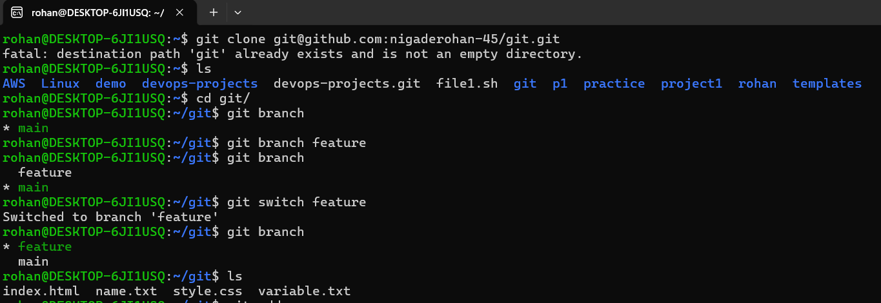
- Create the feature branch and switch it

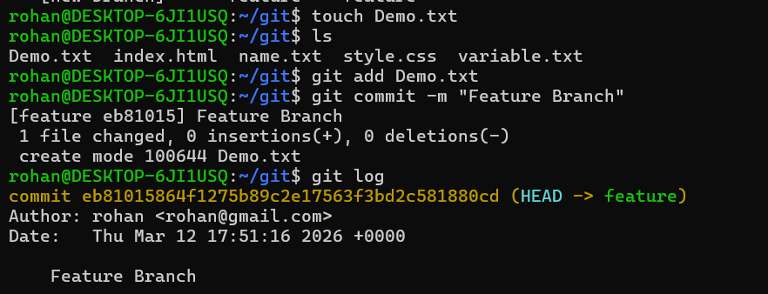
- Add file in git directory and Add it,Commit it and check it

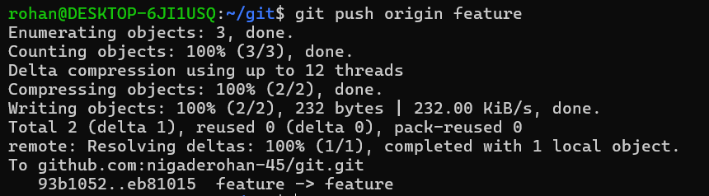
- Push the file to new branch(Feature branch)

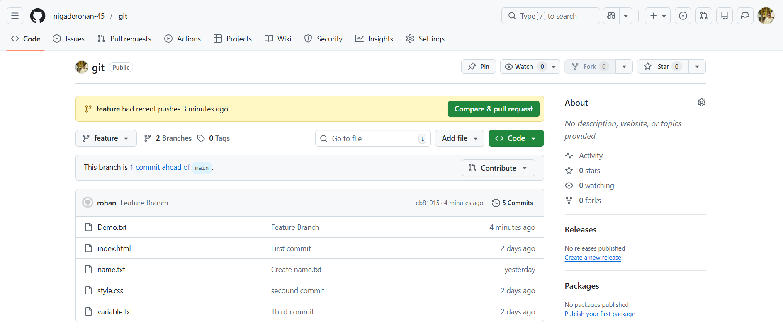
- Branch is added and all files are see
- There are Two branches
- Main branch , Feature Branch
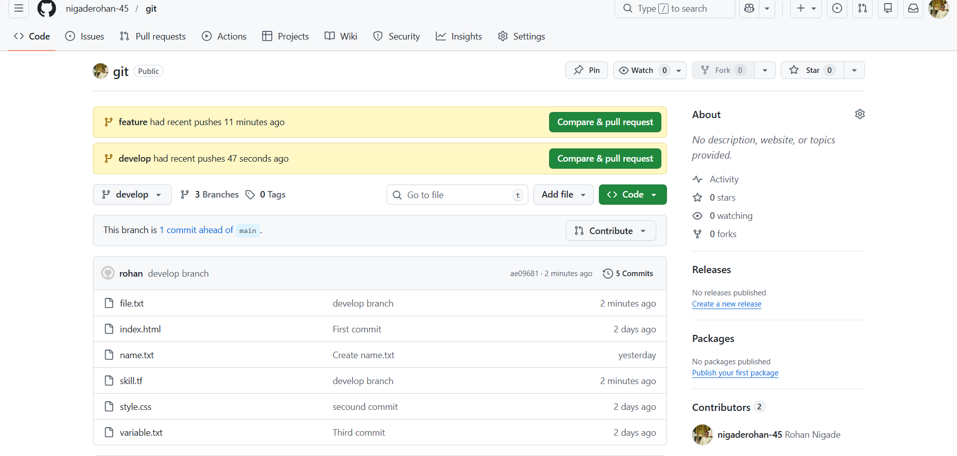
- We create another develop branch and push 2 files in it .
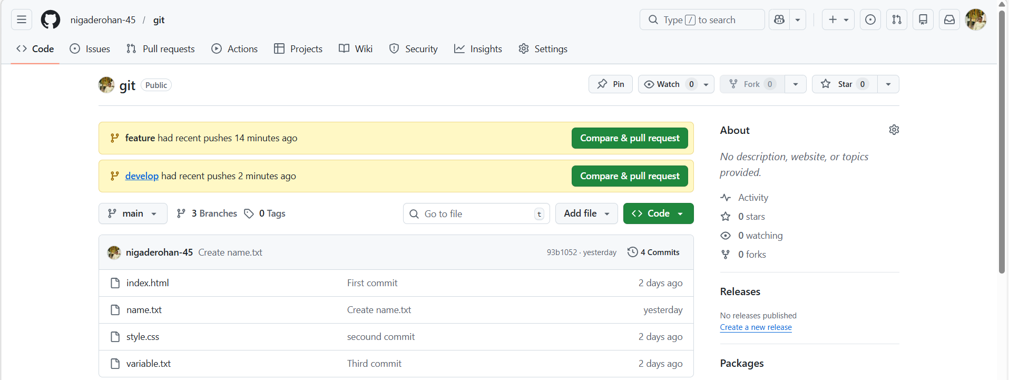
In Other branch we create a files those files are not added in mian branch hence we perform a merge command to add other branches files in main branch
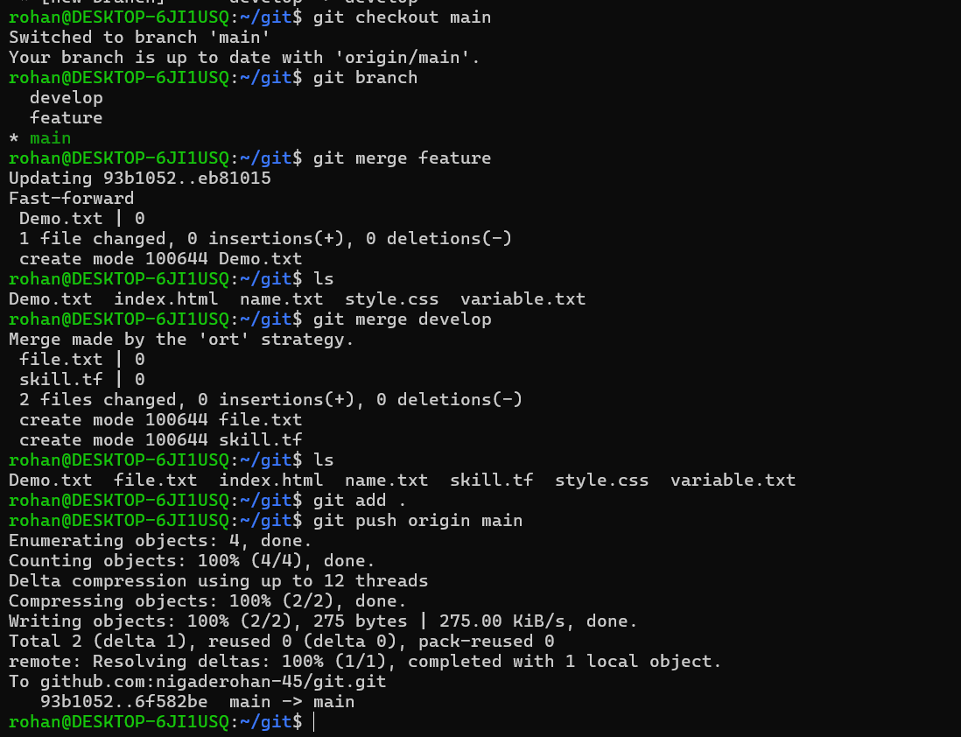
- We merge the branch
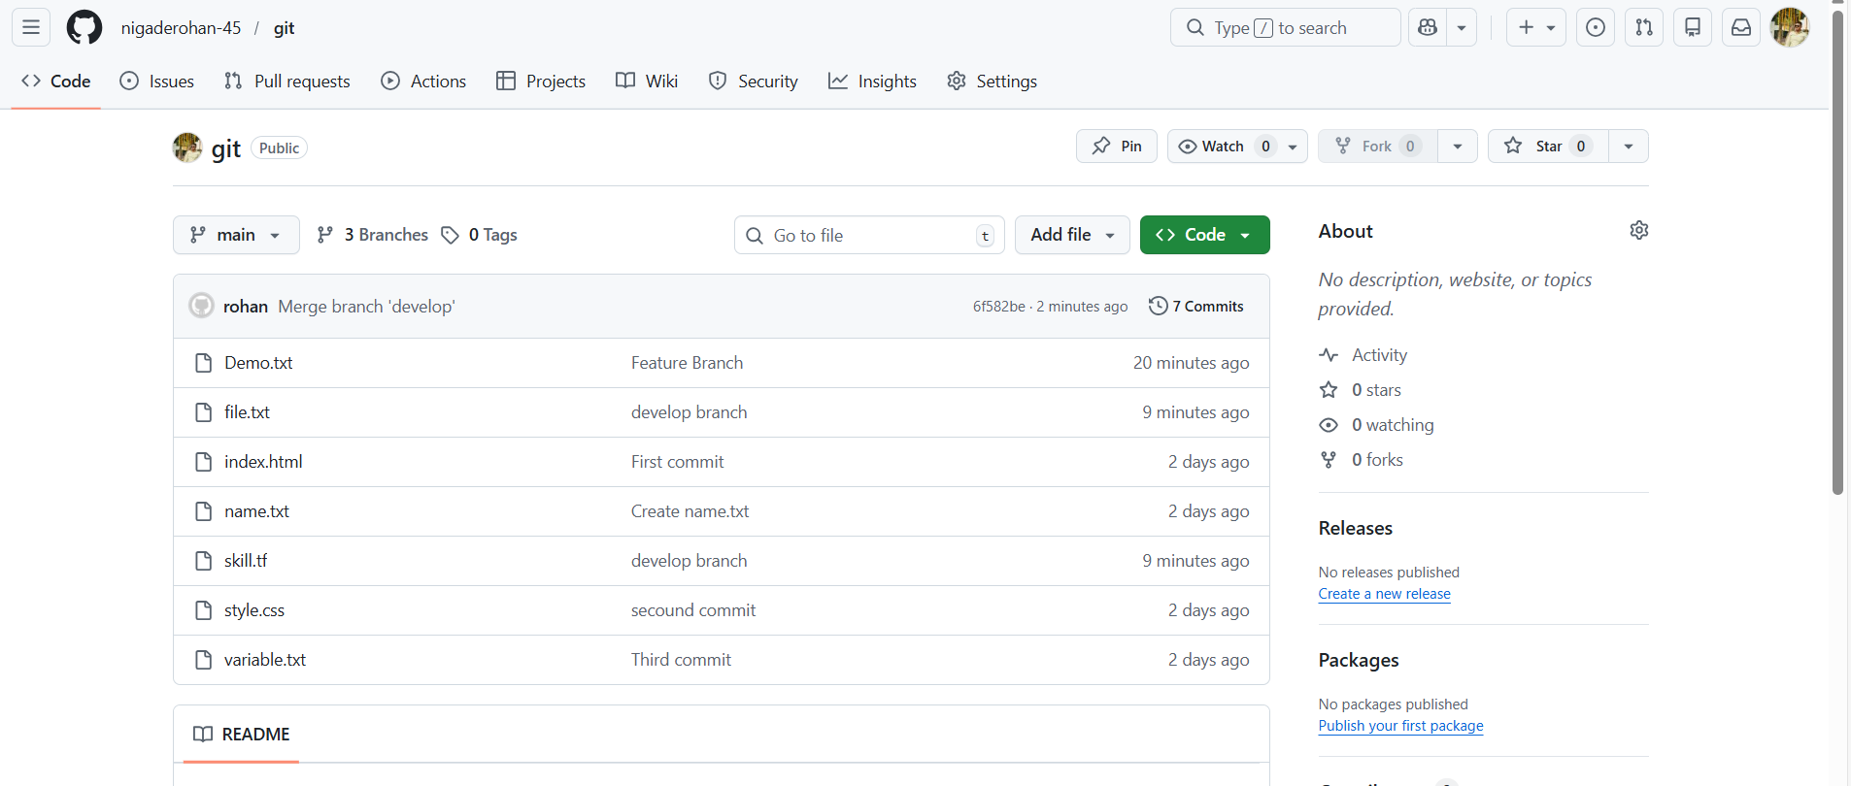

Add other branch files in main branch

